UNNAT BHART ABHIYAN

REPORT ON
REGIONAL WORKSHOP FOR ORIENTATION OF PARTICIPATING INSTITUTES TO INITIATE WORK IN ADOPTED VILLAGE CLUSTERS, 26th Feb. 2020

UBA Nodal Officer : Prof. G. Nagaraja
UBA Coordinator : Dr. P. Srinivas
Email Id : nagarajag918@gmail.com
Name of the activity: Regional Workshop for Orientation of Participating Institutes too Initiate Work in Adopted Village Clusters” at RCI, UBA, Andhra University, Visakhapatnam.
Description
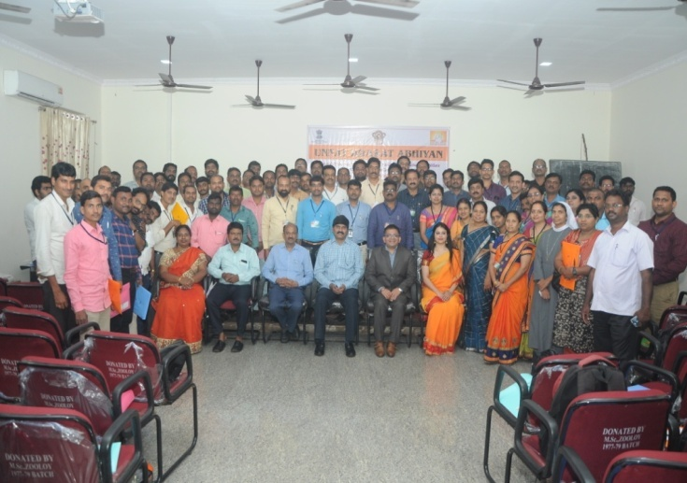

Programme Schedule
Time | Subject | Name of the Facilitator
9-30- 10-00 AM | Registration | -
Inaugural Session
10-00 to 10-30 AM | Inaugural Address and Introduction to Workshop & UBA | -
10.30 to 10-45 AM Tea Break
10-45 to 11-30 | About UBA | Dr. Dibakar Rakshit  Associate Professor,  CES, IIT Delhi
11-30-12-00PM | Framework of UBA | Manavee Ajit Singh  Project Scientist UBA  NCI, IIT New Delhi
12-00-1-00 PM | Funding and Convergence Possibilities | Manavee Ajit Singh  Project Scientist UBA  NCI, IIT New Delhi
1-00 to 2-00 Lunch Break
2-00 to 3-00 PM | Subject Expert Groups(SEGs) | Manavee Ajit Singh  Project Scientist UBA  NCI, IIT New Delhi
3-00 to 3-30 PM | Web Portal | Manavee Ajit Singh  Project Scientist UBA  NCI, IIT New Delhi
3-30 to 4-00 PM | Queries | Manavee Ajit Singh  Project Scientist UBA  NCI, IIT New Delhi
4-00 to 4-15 Tea Break
4-15 to 5-00 PM | Concluding Remarks  Vote of Thanks | -

Chief Guest : Prof. P.V.G.D Prasad Reddy, Vice Chancellor, Andhra University,Visakhapatnam
Guest of Honours/ Resource Persons: Dr. Debakar Rakshi, Associate Professor, CES, IIT Delhi,
Manavee Ajit Singh Singh, Project Scientist UBA, NCI, IIT New Delhi
President: Prof. G. Nagaraja, Nodal Officer, RCU, UBA, Andhra University, Visakhapatnam.

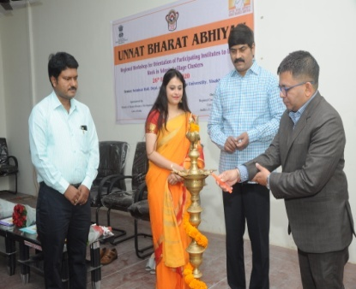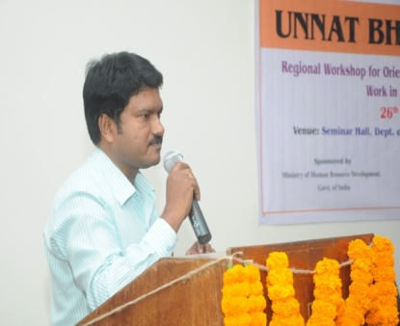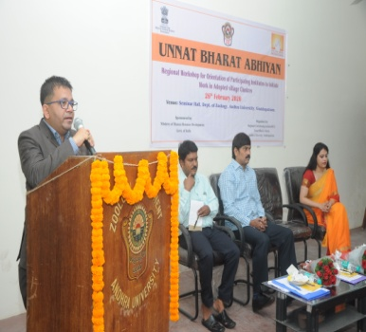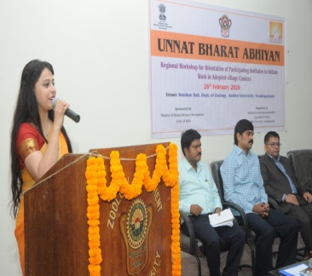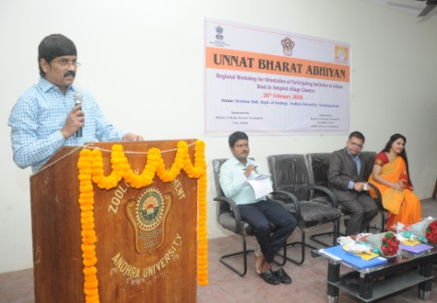

Prof. PVGD, Prasad Reddy, Vice Chancellor, Andhra University,Visakhapatnam, Dr. Debakar Rakshi, Associate Professor, CES, IIT Delhi, Manavee Ajit Singh Singh, Project Scientist UBA, NCI, IIT New Delhi and Prof. G. Nagaraja, Nodal Officer, UBA, RCI, Andhra University, Visakhapatnam in Inaugural session and address the coordinators of PIs.

Report of Orientation workshop Inaugural

Andhra University as a Regional Co-ordinating Institute of Unnat Bharat Abhiyan (UBA), organised regional workshop for orientation of participating institutes to initiate work in Adopted village clusters. The program was started at 9:30 am with registration of representative of 94 participating institute. The details of the registered participants are tabulated in annexure-I. The Vice Chancellor of Andhra University, Prof.P.V.G.D.Prasad Reddy, inaugurated the workshop at Seminar Hall of Zoology Department at 10.00 AM on 26-2-2020. The Nodal officer of the UBA, Prof.G.Nagaraja, presided over the function. Prof.Manavee Ajit Singh, Professor from IIT, New Delhi, is the Project Scientist, UBA, National Co-ordinating Institute addressed the gathering. And also Prof. Dibakar Rakshit graced the occasion. Nearly 94 Co-ordinators of the Participating Institutes from different parts of the state attended the programme. In his inaugural address the vice chancellor of Andhra University highlighted the importance of the UBA by explaining the initiatives taken by Government of Andhra Pradesh. V.C. Suggested the coordinators to work along with the village secretaries who are already on job to identify the local problems and provide solution which prevailed in rural areas. With cooperation of village secretaries we can achieve faster results in implementing the programme. He promised that whatever support required for the better implementation of the programme will be provided from the University as Regional coordinating institute. Target based implementation helps to make the programme successful.
Thereafter Dr. Debakar Rakshi, Associate Professor, CES, IIT Delhi highlighted the about UBA programme and Manavee Ajit Singh Singh, Project Scientist UBA, NCI, IIT New Delhi have highlighted how to implement this programme very effectively, and what is role of coordinator of PIs in effectively implementation of this programme. The event was coordinated by Prof. G Nagaraja Nodal Office, RCI, Andhra University, Visakhapatnam.

Report on the Technical Session:

There were 94 Participating Institutions Coordinators in the programme. Dr. Debakar Rakshi, Associate Professor, CES, IIT Delhi discussed about UBA programme. UBA Network Themes, Plan of Action to be followed up as Participating Institutes, funding and convergence possibilities from Central and State Government Scheme and Programmes, CSR Support for UBA, Demonstration of Web Portal conducted by. Participatory Rural Appraisal, Role of Subject Experts Groups (SEGs) delivered by Manavee Ajit Singh Singh, Project Scientist UBA, NCI, IIT New Delhi. During interaction session, the participants raised their queries and problems related with Village Development Plan. How to overcome technical problems while feeding data in UBA Portal? How to write proposals for financial support? Some of the participants brought up to upgrade the UBA in Higher Secondary Level in order to solve the problems created with least number of Colleges/ Universities. Most of the Participants requested to provide certificates for students’ participation under UBA to encourage and bring passion in them to involve more in the UBA activities. All the queries and problems were cleared by Manavee Ajit singh,Dr. P Srinivas, Coordinator, RCI, UBA and N.Ramesh Babu, T. Hari babu Coordiantors of PIs. The important suggestions and requests were noted down to put to the Higher Authority and necessary actions to follow up.

Outcome of the Programme:

This programme has enriched the Participating Institute Coordinators and other Institute representatives to effectively participate in the holistic development in their adopted
villages using eco-friendly sustainable technologies and local resource creating sufficient employment opportunities in the process, harnessing multifarious government schemes, customised use of existing technologies and use of knowledge as per the local needs, to improve the livelihood of the rural masses. The workshop has reputed the enthusiasm of the
coordinators and other participants in the workshop to actively involve themselves and their
expertise to execute the UBA mission in their adopted villages.
Future Plan

Submission of Project proposal

RCI, Andhra University, Visakhapatnam instructed to all PIs for submission of new project proposals. This information has been already sent to the all PIs through the email and also requested on “One-Day Regional Orientation Workshop for Participating Institute under UBA 2.0 on 26th February 2020.

Annexure-1
List of Participants in Regional Orientation Workshop on 26-02-2020, RCI Andhra University Visakhapatnam
SL.NO | COLLEGE CODE | COLLLEGE ADRESS | CO-ORDINATOR NAME | CO-ORDINATOR EMAIL | MOBILE NUMBER
1 | C – 24195 | A.B.M.DEGREE COLLEGE,  BR COMPLEX, NEAR UNION BANK,  RAMARAO PETA,  NARSIPATANAM, PIN - 531116 | P.SATYANARAYANA | asr5153@gmail.com | 9247476831
2 | C – 24322 | Dr. HIMA SEKHAR DEGREE COLLEGE,  NEAR SANKAR THEATER,  D.NO: 20-7-5/9. ANAKAPALLI,  VISAKHAPATNAM  PIN-531001. | KOMMOJU RAMESH | akp3039@gmail.com | 9030387776
3 | C – 21460 | VIVEKANANDA DEGREE COLLEGE,  ANAKAPALLI ROAD  NEAR BAJAJ SHOW ROOM  NARASIPATNAM-531116 | Y.V.BHASKAR BABU | yerravbhasakarababu@gmail.com | 9849535306
4 | C – 23936 | GOVT. DEGREE COLLEGE  CHODAVARAM  VISAKHAPATANAM - 531036 | Dr.S.SATYANARAYANA | satyanarayana.sirisatti@gmail.com | 9849416374
5 | C – 23989 | PUNYAGIRI DEGREE @ PG COLLEGE  S.KOTA VILLAGE  VIZIANAGARAM (DT)  PIN: 535145 | GANIVADA SATISH | satishganavada@gmail.com | 8500900617
6 | C- 27195 | PRAGATHI DEGREE COLLEGE  KOTHAVALASA VILLAGE  VIZIANAGARAM (DIST)  PIN :- 535183 | GOVADA APPALA NAIDU | siddugovada@gmail.com | 9000986189
7 | C - 24063 | POORNA SAI VIVEKANDA DEGREE COLLEGE  COURT PETA  YELLAMANCHIL – 531055 | PILLA APPALA NAIDU | pilla1978@gmail.com | 6304771656
8 | C – 24087 | GOVT DEGREE COLLEGE  NEAR RAMALAYAM  SUNDRUPUTTU  PADERU  PIN :- 531024  VISAKHAPATANAM | D.DURYODHAN | gdcpaderu.ac.in@gmail.com | 9110732848
9 | 399 | KML DEGREE COLLEGE  RAVADA KANAL ROAD  SABBAVARAM VILL & MD  VISAKHAPATANAM – 531035 | KILLI LAKSHMANA NAIDU | lakshmananaidu1981@gmail.com | 9373153999
10 | C – 55173 | JAI ARINA DEGREE COLLEGE  MAIN ROAD,  KOTHAKOTA – 531114 | PILLA SRINIVASA RAO | jaiarinadegreecollege@gmail.com | 7013546526
11 | C – 24226 | SRI SAI PRAKASH DEGREE COLLEGE  NEAR KONAM GUEST HOUSE,  LAXMIPURAM ROAD,  CHIDAVARAM – 531036 | N.APPALA NAIDU | naidu.nambaru@gmail.com | 8790852540
12 | C – 54606 | DON BOSCO DEGREE COLLEGE  BOSCO NAGAR  PEDDABODEPALLI  NARSIPATNAM - 531116 | V.BENNY MATHEW | donbosconpm@gmail.com | 6302203508
13 | C – 24160 | GOVT DEGREE COLLEGE  CHINTAPALLI ROAD  NARSIPATNAM – 531116 | M.VENKATESWAR RAO | marubalca71@gmail.com | 8790934202
14 | C – 23822 | CHANAKYA INSTITUTE OF HOTEL MANAGEMENT  D.NO:- 47-14-9,  POTLURI CASTEL,4th FLOOR, ABOVE HDFC BANK,  DWARAKANAGAR MAIN ROAD,  VISAKHAPATANAM - 530016 | UMA MAHESH | vumahesh.cihm@gmail.com | 8977163777
15 | C – 27166 | SREEPAADA DEGREE COLLEGE  NEAR R&B,RTA OFFICE ROAD  MADHAVADHARA,  VISAKHAPATNAM – 530018 | T.SURESH REDDY | sreepaada.ug@gmail.com | 8919734071
16 | C – 24436 | A.M.A.L.COLLEGE,  ANAKAPALLE | Dr.M.HARI BABU | haribabu.mylabathula@gmail.com | 9989544361
17 | C – 23920 | GOVT DEGREE COLLEGE  V.MADUGULA  V.MADUGULA,(MANDAL)  VISAKHAPATNAM – 531027 | M.RAMKUMAR | ramkumarmalla6@gmail.com | 9494569121
18 | C – 24367 | RANGUMUDRI DEGREE COLLEGE  CHILAKAPALLI (VILLAGE)  BALIJIPETA (MANDAL)  VIZIANAGARAM (DT) – 535557 | M.TRINADHA | rangumudridegreecollege@gmail.com | 9553897768
19 |  | GOVT DEGREE COLLEGE  CHINTAPALLI (VIL & MAD)  CHOWDUPALLI ROAD  VISAKHAPATNAM – 531111 | Dr. GANESH LEKKALA | varada830@gmail.com | 9492783814
20 | C – 24440 | S.G.A.G.D.C  YELLAMANCHILI  VISAKHAPATNAM – 531055 | Dr.B.LAXMI | sonikanirman@gmail.com | 9989817442
21 | C – 24479 | BUDDHA RAMESH BABU MEMORIAL DEGREE COLLEGE,(SRI CHANAKYA DEGREE COLEGE)  36-46-3  NEERANJANEYA COMPLEX  MAIN ROAD, KANCHARAPALAM,  VISAKHAPATNAM – 530003 | A.H.V.SURYA CHANDRA RAO | arichananyadegreecolleges@gmail.com | 9490261483
22 | C-23923 | CHAITANYA DEGREE & PG COLLEGE FOR WOMEN  CHAITANYA NAGAR  OLD GAJUWAKA  VISAKHAPATNAM – 530026 | Y.V.N.LAKSHMI | yvnlakshmi21091974@gmail.com | 9948980809
23 | C-24449 | ADITY DEGREE COLLEGE  CHAITANYA NAGAR  BESIDE BHASHYAM SCHOOL  GAJUWAKA. 530026 | K.SHIVA KRISHNA | sivakrishna09071989@gmail.com | 9573248106
24 | C – 23890 | MVR DEGREE & PG COLLEGE  SHRAMIKA NAGAR  CHINAGANTYADA  GAJUWAKA, VSKP-530026 | S.K. SRINIVAS | susarlasrinivas2011@gmail.com
25 | C – 24051 | HINDUSTAN SHIPYARD DEGREE, GANDHIGRAM  SCINDIA, VISAKHAPATANAM  530005 | N.SANKARA VARA PRASAD | hsdc19991@gmail.com | 7842905946
26 | C – 24133 | RAJAH R.S.R.K RANGA RAO COLLEGE  NEAR R.T.C BUS STAND,  BOBBILI  VIZIANAGARAM – 532228 | M.RAMESH | ramesh21.mandala@gmail.com | 9247110149
27 | C – 23941 | Dr. V.S. KRISHNA GOVT DEGREE COLLEGE  MADDILAPALEM.  VISAKHAPATANAM | Dr.DODDI PRAVEEN | praveenaphdtelugu@gmail.com | 9394439137
28 | C – 24057 | MAHARAJAH’S POST GRADUATE COLLEGE  PHOOL BAUGH,  VIZIANAGARAM – 535002 | S.V.N. LAXMINARAYANA | laxminarayanasvn73@gmail.com | 96656573132
29 | C - 24266 | DR.NO :- 52 – 14 – 72  NEW RESAPUVANIPALEM,  VISAHHAPATANAM - 530013 | SK.GOWSI BABU | shaik786gowsibabu@gmail.com | 9848424955
30 | C – 24441 | S.K.M.L DEGREE COLLEGE  OPP LIC BUILDING  MAIN ROAD YALAMANCHILLI  VISAKHAPATNAM – 531055 | N.B.SUNDARAM | nbsundaram555@gmail.com | 9949270513
31 | C – 24104 | USHODAYA DEGREE COLLEGE,J SOMMUNAIDU VIDHYA PRAGANAM  BEHIND LAKSHAMMA TEMPLE, CHODVARAM  VISAKHAPATNAM – 531036 | SASUBILLI NOOKU NAIDU | komala.yk@gmail.com | 9948746344
32 | C – 54182 | KITES DEGREE COLLEGE  NEAR SBI, BHOGAPURAM ROAD, SAINAGAR,  ACTHUTHAPURAM – 531001 | K.RAVIKUMAR | ravi21990@gmail.com | 7981013954
33 | C – 24212 | BVK DEGREE COLLEGE  DWARAKANAGAR  VISAKHAPATNAM | P.RATNA SEKHARA RAO | ratnasekharbvk@gmail.com | 9441141636
34 | C - | THUMMIKAPALLI (VILL)  KOTHAVALASA (M.D)  VIZIANAGARAM – 535183 | K.SANTOSH KUMAR | kskm8325@gmail.com | 9014576033
35 | C-0356 | PSV DEGREE COLLEGE  COURT PETTA,YLM.  VISAKHAPATNAM-531103 | GUDALA ARJUNA RAO | 2vreddynaidu@gmail.com | 7702340051  8008890936
36 | C-23937 | SRI MURALIKRISHNA DEGREE COLLEGE  OPP MORE SUPER MARKET  GOPALAPATNA,VSKP-530027 | T.PRATAP KUMAR | srimuralikrishnacollege@gmail.com | 9848166119
37 | 270 | UNITY DEGREE COLLEGE  SIRIPURAM, OPP TYCOON RESTARANT.VSKP | SHANMUKHA M.LAVEEN | placement@unitydegreecollege.com | 9346004386  9966652866
38 | C-26817 | ADITYA DEGREE COLLEGE  KAKINADA | CH.V.V.SATYANARAYANA | csn@aditya.ac.in | 9618176661
39 | C-13 | GAYATRI VIDYA PARISHAD COLLEGE OF ENGINEERING (A), MADHURAWADA, VISAKHAPATNAM-530048 | Y.C.V.KONAIAH | yvkondareddy@gvpce.ac.in | 9440618879
40 | C- 50908 | WELLFARE INSTITUTE OF SCINCE AND TECHONOLOGY AND MANAGEMENT, PINAGADI, PENDURTHI , VISAKHAPATNAM | RUPPA SAGAR | ruppasagar339@gmail.com | 9971238125
41 | C-23886 | MVMJS&RVR COLLEGE  MALIKIPURAM  EAST GODAVARI-533253 | N.RAMESH BABU | nakkaramesh55@gmail.com | 9866557455
42 |  | ST.ANN’S COLLEGE FOR WOMEN  MALKAPURAM  VISAKHAPATNAM-530011 | B.P.RAJU | boraraju1978@gmail.com | 9912526448
43 | C- 24466 | SRI SAI DEGREE COLLEGE  BOBBILI.VIZIANAGARAM | N.BHASKAR RAO | ssdc.bbl@gmail.com | 9440921855
44 | C-54484 | VIDHYARHI DEGREE COLLEGE, CHODAVARAM  VISAKHAPATNAM | V.ARJUNA RAO | arjun.kam@gmail.com | 9985024520
45 | C-18029 | GIET(A) COLLEGE,  CHAITANYA NAGAR,  RAJAHMUNDRY | K.SEERA RAMA RAJU | seetaramaraju@gmail.com | 9491440602
46 | C-17965 | VIGNES’S INSTITUTE OF INFORMATION TECHNOLOGY  DUVADA,VISAKHAPATNAM | Dr.K.SRISHE | Sri.siri369@gmail.com | 8688753830
47 | U-0009 | Dr.B.R.AU, ETCHERLA  SRIKAKULM | Dr.N.LOKESWARI | lokeswari@hotmail.com | 9052525370
48 | C-24171 | ANITS(A)  SANGIVALASA  VISAKHAPATNAM-531162 | Dr.ANIL IH | anil.che@anits.edu.in | 7382157057
49 | C-24303 | SRI VIVEKANANDA DEGREE COLLEGE, S.KOTA,  VIZIANAGARAM | B.YERNAIDU | Chrk9440429018@gmail.com | 9440429018  9640273499
50 | C-18062 | SRINIVASA INSTITUTE OF ENGINEERING AND TECHNOLOGY  AMALAPURAM, CHEYYEN (V)  EAST GODAVARI | Dr.B.N.JAGADESH | nagajagadesh@gmail.com | 9441958969
51 | C-24230 | MRS A.V.N.COLLEGE  VISAKHAPATNAM | Dr.SIMHADRI NAIDU | mrsavncollege@gmail.com | 7674815231
52 | C-24117 | DADI VEERUNAIDU DEGREE COLLEGE, ANALAPALLI  VISAKHAPATNAM | U.NAGESWARA RAO | dvn@diet.edu.in | 9573999424  9963994095
53 | C-18139 | COSTAL INSTITUTE OF TECHNOLOGYAND MANAGEMENT,NARAPAM,  VEERABHADRAPURAM (PO)  KOTHAVALASA, VIZINAGARAM | S.SIRISHA | s.sirish@citmac.in | 8919941972
54 | C-18066 | LENDI  JONNADA,VIZIANAGARAM | Dr.HARI BABU.T | hatitheuniversal@gmail.com | 9440437025
55 | C- 23871 | M.R.COLLEGE (A), NEAR CLOCK TOWER  YELUGUBANTI VARI STREET  VIZIANAGARAM | G.CHANDRA SEKHAR | sekhar_analytical@yahoo.com | 9494208094
56 | C-54488 | SRINIVASA DEGREE COLLEGE, BALAJINAGAR  VIZIANAGARAM | KVSL NARAYANA RAO | vzmsrinivasa.college@gmail.com | 9052215583
57 | C-24036 | St.XAVIER’S DEGREE COLLEGE,  PENDURTHI, VISAKHAPATNAM | T.THEOPHILUS | st.xaviers@gmail.com | 9546612285
58 | C-24031 | GOVT.DEGREE COLLEGE  S.KOTA, VIZINAGARAM | P.PYDI RAJU | pydiraju.telugu@gmail.com | 9490132364
59 | C-24246 | RISHI DEGREE COLLEGE  NARSHIPATANAM  VISAKHAPATNAM | CH.SRINIVASA RAO | srinivasaraocheepurpall.@gmail.com | 8500637096
60 | C-24216 | SAMYUKTTI DEGREE COLLEGE, ANAKAPALLI,  VISAKHAPATNAM | D.MAHESH BABU | akpsamukthee@gmail.com | 9849607668
61 | C-23996 | VDA DEGREE COLLEGE  GAJUWAKA  VISAKHAPATNAM | T.RAMU | jojibabutompala@gmail.com | 9550748971
62 | C-24174 | VVRKML DEGREE COLLEGE  VISAKHAPATNAM | Dr.PRABHAKAR | Prabhakar_med@yahoo.co.in | 9959111814  9703009945
63 | C-24295 | SATYANARAYANA DEGREE COLLEGE, CHEEPURAPALLI,  VIZIANAGARAM | T.MUKUNDARAO | mukundarraotummarpalli@gmail.com | 9494331965
64 | C-24450 | TSR&TBK DEGREE COLLEGE &P.G COLLEGE  SRINAGAR,GAJUWAKA | PROF P.SUJATHA | drpsujatha@gmail.com | 9441586004
65 | C-24209 | ADARSH DEGREE COLLEGE  NEAR SBI PENDURTHI  VISAKHAPATNAM | N.E.FLORA | theiflora@gmail.com | 9246412285
66 | C-241701 | ANIL NEERUKONDA INSTITUTE OF TECH & SCIENCE  SANGIVALASA  VISAKHAPATNAM | Dr.K.S.DEEPTHI | Uba_anits@anits.edu | 9440187827
67 | C-18084 | BVC ENGINEERING COLLEGE,  ODALAKEM  EAST GODAVARI | Dr.T.V.JANARDHANA RAO | dean.admidssions@bvcgroup.in | 9490124094
68 | C-24076 | SPACES DEGREE COLLEGE  PAYAKARAOPETA  VISAKHAPATNAM | D.MANIKYAM | srinidi.manikyam@gmail.com | 9059208469
69 | C-24325 | GOVT.DEGREE COLLEGE  GUMMALAKSHMIPURAM,  VIZIANAGARAM | M.RAVI KIRAN KUMAR | ravi.kiranmedari@gmail.com | 6303768511
70 |  | S.S.S.S DEGREE COLLEGE  NAIDU COLONY  THOTAPALAM VIZIANAGARAM | K.VENKU NAIDU | kvnaidu862@gmail.com | 9701953397
71 | C-24448 | GOVT. COLLEGE (A)  RAJUMUNDRY  EAST GODAVARI | B.GEETHA DEVI | boddudevi2013@gmail.com | 9490360822
72 | C-39249 | SSS DEGREE COLLEGE  BOBBILLI, VIZIANAGARAM | V.VENKATA RAMANA | vvr7940@gmail.com | 9963792423
73 | C-24015 | VAGDEVI DEGREE COLLEGE  KOTAVALASA, THUMKAPALI  VIZIANAGARAM | CH.KANAKA NAIDU | k.k.naidu1987@gmail.com | 9912729430
74 | C-24308 | PROF.G.SUNDARA REDDY DEGREE COLLEGE, SRINIVAS NAGAR, SALUR,  VIZINAGARAM | CH.SRIDHAR BABU | g.s.r.dsalur.2012@gmail.com | 9032467278  8886714533
75 | C-24179 | EMMANUEL DEGREE COLLEGE, TAMRAM  MAKAVARAPALAM  VISAKHAPATNAM | B.SUDHAKAR | emmanueltamaram@gmail.com | 9394412512
76 | C-24358 | SRI GAYTHRI DEGREE COLLEGE, BOBBIL,  VIZIANAGARAM | K.UMA MAHESWAR |  | 9963746645
77 | C-24472 | GEETANJILI DEGREE COLLEGE, YELLAMANCHILI  VISAKHAPATNAM | K.SRINIVASU | shrg123@gmail.com | 9441326676
78 | C-21460 | VIVEKANANDA DEGREE COLLEGE, NARSIPATNAM  VISAKHAPATNAM | Y.V.BHASKARA BABU | yerravbhasakarababu@gmail.com | 9849535306
79 | C-17915 | RAGHU ENGG COLLEGE  DAKAMARRI BHEMINIPATANAM  VISAKHAPATNAM | B.S.V.REDDY | bsvreddy.rec@gmail.com | 9440367494  9963261138
80 | C-23893 | SRI P.S.S.R DEGREE COLLEGE,  MOIDA JUNCTION  NELLIMARALA VILLAGE  VIZIANAGARAM | BHAYI ANANDA RAO | anandbhayi@gmail.com | 7036030126
81 | C-24465 | S.V.KRISHNA CHANDRA DEO DEGREE COLLEGE  KURAPAM,VIZIANAGARAM | G.MAHENDRA | mahendraram@gmail.com | 9381867813
82 | C-24437 | AGL DEGEE COLLEGE  VIZINAGARAM | R.VENKATA RAO | venkataraoreddi3@gmail.com | 9440192498
83 | C-24445 | SRI SATYA SAI DEGREE COLLEGE, SALUR | D.V.G.H.S PATNAIK | sssdcslr@gmail.com | 9440357503
84 | C-271 | ACTS DEGREE COLLEGE  YENDADA,VISAKHAPATNAM | N.P.V.L.DEVI PADMA RAO | actsvicag@gmail.com | 9908236063
85 | C-23916 | RK DEGREE COLLEGE  MAYURI JUNCTION  VIZIANAGARAM | K.YELLAM NAIDU | rkcollegevznm@gmail.com | 9490462346
86 |  | S.V.D.COLLEGE  THERLAM,VIZINAGARAM | T.RAMA RAO |  | 9441389967
87 | C-24099 | I.G.DEGREE COLLEGE  BOBBILI,VIZINAGARAM | B.VENKARA RAMANA | venkat.buditi@gmail.com | 9440973808
88 | C-24184 | VIDWAN DEGREE COLLEGE  BOBBILI,VIZIANAGARAM | CH. NAVEEN | chintadanaveen2555@gmail.com | 6301075158
89 |  | S.V.R DEGREE COLLEGE  CHEEPURAPALLI  VIZIANAGARAM | V.BANAGRU NAIDU | bangraunaiduvalluru@gmail.com | 94440450360
90 | C-24035 | S.K. DEGREE & P.G COLLEGE  AYYANNAPETA  VIZIANAGARAM | G.APPA RAO | Garao10269@gmail.com | 9492995685
91 | C-24010 | ATCHUTA DEGREE COLLEGE  ATCHUTAPURAM | L.BHARGAV | atchuta916@gmail.com | 9441141145
92 | C-0464 | SRI SAI RAM DEGREE COLLEGE | R.SRINIVAS RAO | principalssrdcollege@gmail.com | 9441749947
93 | C-18044 | VIGNAN’S INSTITUTE OF ENGINEERING FOR WOMEN  VISAKHAPATNAM | Dr.DURGA SYAM PRASAD | ksurgasyam@gmail.com | 9553.371222
94 | C-24256 | PMN DEGREE COLLEGE  GOTTIVADA  SABBAVARAM | Dr.K.PRABHAKAR | Prabhakar_med@yahoo.co.in | 9959111814

